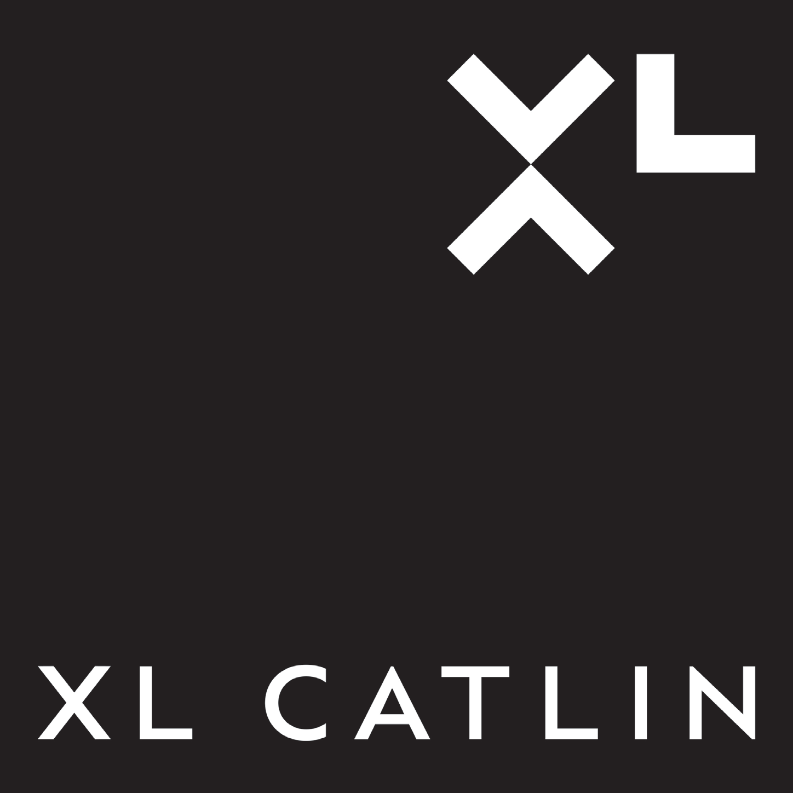**Application Landscape**



Relationship

Management

Business

Development

Risk

Submission

Risk

Data Entry

Risk

Decisioning

Policy Bind &

Issue

Policy Premium

Collection

Claims

Notification

Claims

Adjustment

Claims Date

Entry & Admin

Portals

CRM

Product

Management

Risk

Decisioning

Policy

Admin

Billing

Claims

Management

# Relationship Management

Risk Submission

Risk Data Entry

Risk Decisioning

Policy bind & Issue

Policy Premium Collection

Claims Notification

Claims Adjustment

Claims Data Entry & Admin

Outwards Risk Transfer

Financial Management

Employee Management

Common Components

CATS DAD

BPT & CPT

Legacy Catlin US Portals

Cargo & Life

LMS

RMS Risklink A/R XCAT

FRS Stored River

Procede

Reserving & S2 Provisions

RPE

Regional HR

- Eg Payroll

CS Doc Repository

Workflow (Sharepoint)

Filemaker

Filemaker

First Best

Equine Online (Wildnet)

ClaimsGate Filemaker

GUP

GAPS

DuckCreek

Filemaker

Angal suite( and supporting spreadsheets )

ClaimGate SwordFish

PCM ITBP HBF

Hyperion Planning

Consolidation (Hyperion)

HRSS

(Oracle EBS)

HRMS

(Peoplesoft)

Frame P2P Messaging

Document Management (Image Right)

Exari

Frame Bureau messaging

Integration Informatica Webmethods

Secure Access Layer

Doc Gen (Thunderhead)

CDS (MS

Dynamics) CAM

US Portal

XL Catlin Advantage (FL)

DuckCreek

Guidewire Policy Center

UWS

Guidewire Billing Center

Concept 1

Phoenix

Subscribe (NIIT)

Guidewire Claims Center

WINS (XL)

Sun Systems OIM Brazil

Sun Systems China GL

Topsides

GL (SAP)

My HR

(HCM Cloud)

Global Payroll Services

Frame Doc Repository

Frame Document Production

Proclarity and Others

Liason messaging

Doc Gen (ITP Aia)

MDM

(Kalido) Cognos

Doc Gen iStream Oracle

The Frame

Document

Insurance

Claims

Outwards

GAAP2

Doc Mgt. (Documentum)

User Access

CDI (IBM)

P2P

Salesforce

XLAPS

Pricing DBs

XLeRate

CRISS

EDW

Production

Data

Ledger

Global genius (Xuber) China Genius (Xuber)

Destiny SAP C&D

US Copy of

XL Global Claims Accenture CS Star (TPA)

Recoveries

Mainline

EE

Peoplesoft General Ledger

Calculation Engines & AED

ADI -

Adjustments

Financial Accounting Hub

eBusiness Suite Shadow Ledger

Conforming

Workflow (EMC)

Workflow (DIVA)

Retire

Platform

{Temenos} BizTalk

Consolidate

Enterprise Data Warehouse



CUAL

GuideWire LODS

Operational Functionality

Frame ODS IDW ODS

Warehouse

Group DWH

Combined ODS

Reinsurance Datawarehouse

Report etc

Functional Datamart

Layer EFR

Reduced Scope New

Strategic